Asteroids

**Description**

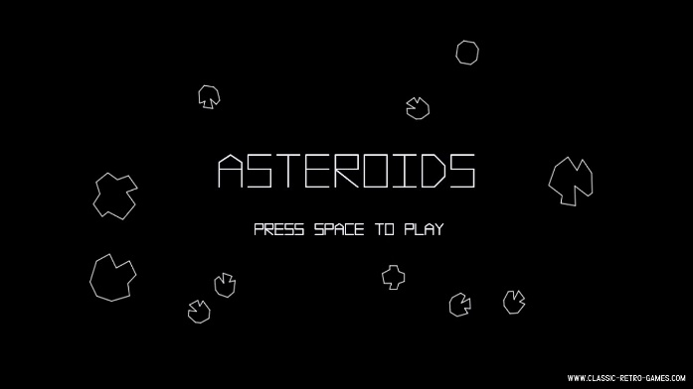Asteroids is a multidirectional shooting game based on a space theme released in November 1979. The player controls a triangular shaped spaceship, and the object of the game is to shoot and destroy the asteroids coming from all directions in the field and avoid collision at the same time. Each asteroid destroyed will bring the score up by 1, and each round is 60 seconds. To enter the high score board, player needs to destroy asteroids as fast as he can during the 60 seconds.

The original version ASTEROIDS game released in 1979

**Installation Instruction**

Download the compressed file and decompress it. Open Eclipse and click the File button at the top left corner. Choose create new project and import the file folder decompressed from the compress file to the src folder. Right click the Project imported and click Run As. Click the 1 Java Application option and choose Main – application then click OK.

**Features**

-Using UP, DOWN, LEFT, RIGHT keys to control the movement of the space ship. The UP and DOWN key give the space ship velocity toward front or back, and LEFT and RIGHT key turn the face of the spaceship to left or right.

-Using CONTROL, ENTER or SPACE keys to shoot bullets.

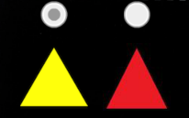

-Two different Spaceship provided.

Screen shot of the two options of the spaceship

-Showing scores and WIN/LOSE after each round of game.

-Simple Instruction on the menu.

-High Score Board

-Timer and number of lives left show at the top left corner.



Screenshot of the Lives and timer

**Screen Shots from Game**

